Kaarel PArt

Documentation for the prototype portion of the Nea coursework
Prototype
Computer Science NEA

Contents
Features included in the prototype 2
Features not included in the prototype 2
Prototype 3
Evaluation of current system 11
Shortcomings and improvements 11

Features included in the prototype
Identify the different aspects of the system you will be including in your Prototype and justification as to why you have included these.
Feature | Justification
Main Dashboard | Necessary for the program to work and easy to make
My bookings | Necessary for the program to work and easy to make
Rooms | Necessary for the program to work and easy to make
Admin page | Necessary for the program to work and easy to make
FAQ | Necessary for the program to work and easy to make
Contact Support | Necessary for the program to work and easy to make
Room List | Necessary for the program to work and easy to make
Room Details | Necessary for the program to work and easy to make
Logout & Login | Necessary for the program to work and easy to make
Booking Process | Necessary for the program to work and easy to make
View Bookings | Necessary for the program to work and easy to make
Support & Help | Necessary for the program to work and easy to make
Manage bookings | Necessary for the program to work and easy to make
Manage Users | Necessary for the program to work and easy to make

Features not included in the prototype
Identify the different aspects of the system you will be including in your Prototype and justification as to why you have not included these.
Feature | Justification
System Settings | Felt that it was unnecessary to have it and will probably not have it in the main design either as the whole thing with this is its supposed to be easy to use and if anything really does need to be changed id rather have it as a permanent patch to the source code and rebuild redeploy that instead of a change in runtime which is more limited, less reliable and would need some extra place to store it in like a settings.json or something like that
Notifications | Notifications haven’t been added and so with bookings notifications since I wanted to have it with emails as in app notifications seems a bit pointless if the user needs to be active logged into the system to see them. Also, it would look nicer in an email I feel like and would not have worry about external notifications too since both will be covered by email
Check in/out to meeting | The prototype implementation of the actual bookings was really badly made in terms of the backend which made it really complex to have every other user see changes that one user had made and more as a way for me to demo it via admin panel and manually changing stuff there however in real one it will be much better and this feature will definitely be part of it
Priority Alerts | Same as notifications as overall alerts and stuff haven’t been done yet in the prototype and as said it will be in the actual one.
Edit/Cancel booking | This is half done with cancelling being possible however as said with the check in out meeting the prototype version is currently very admin controlled and the user having a more read only view of booked into bookings however in production as said before it will definitely be more proper

Prototype

Login screen
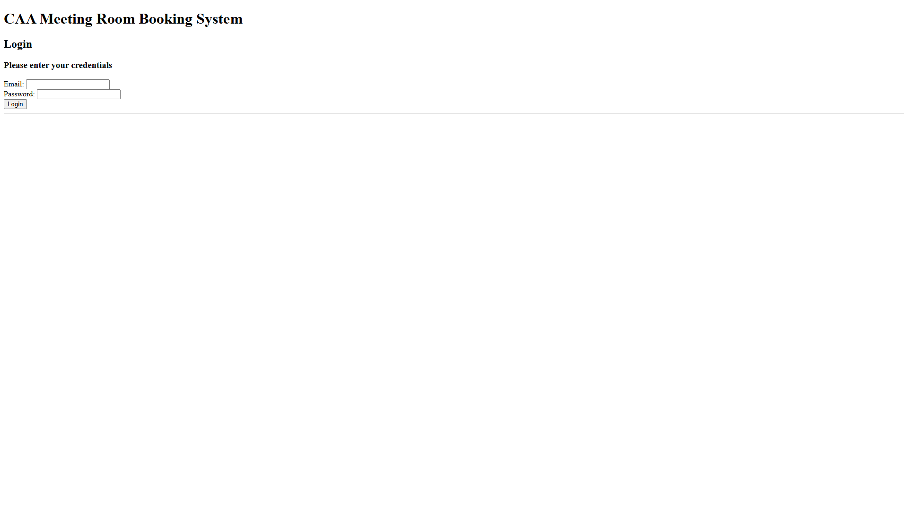

Wrong email
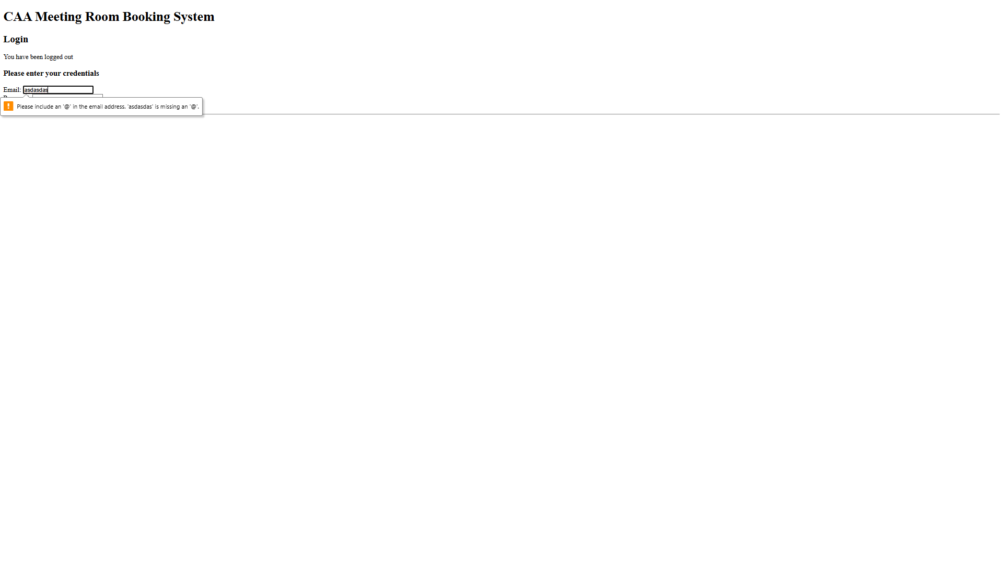

Invalid credentials
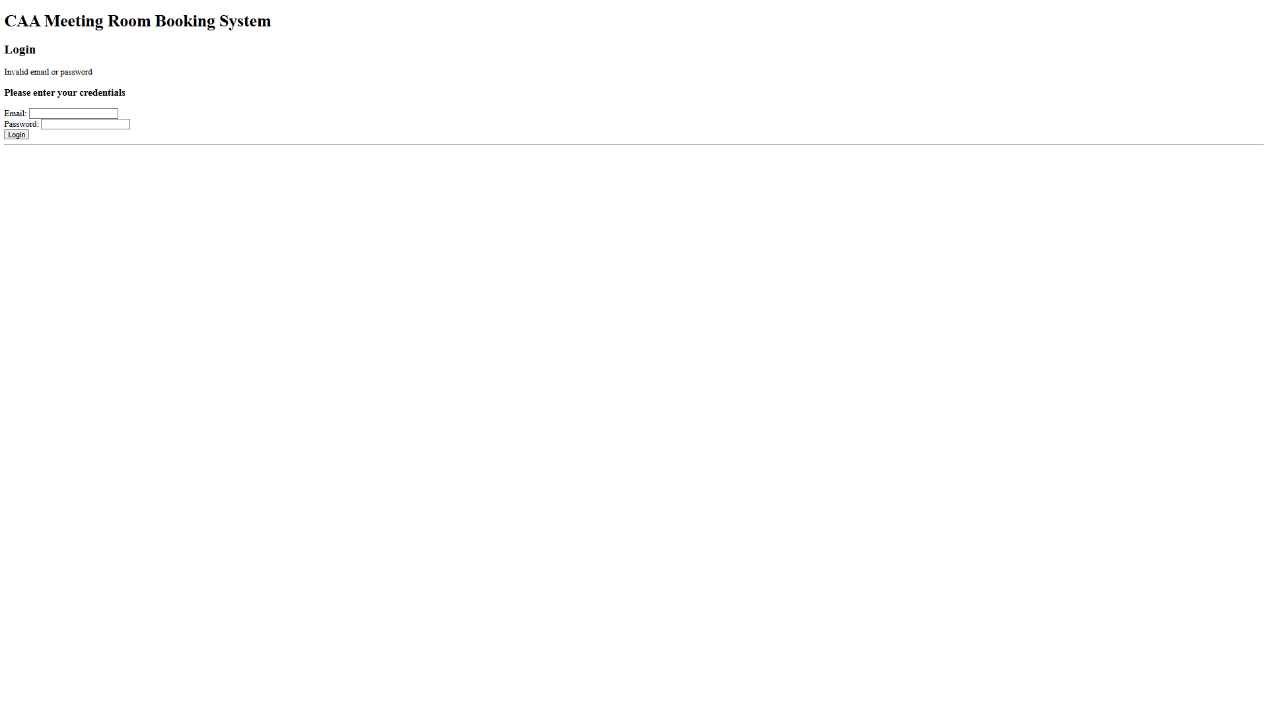

Main dashboard
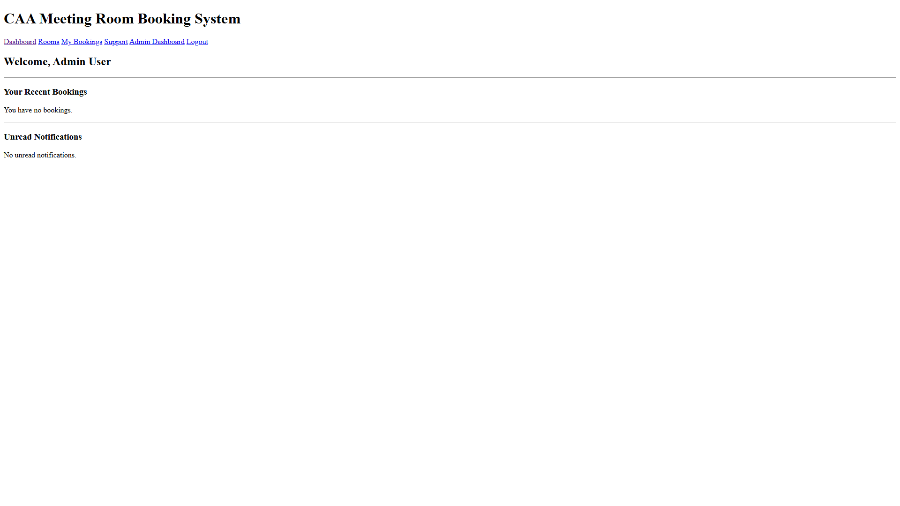

with a booking
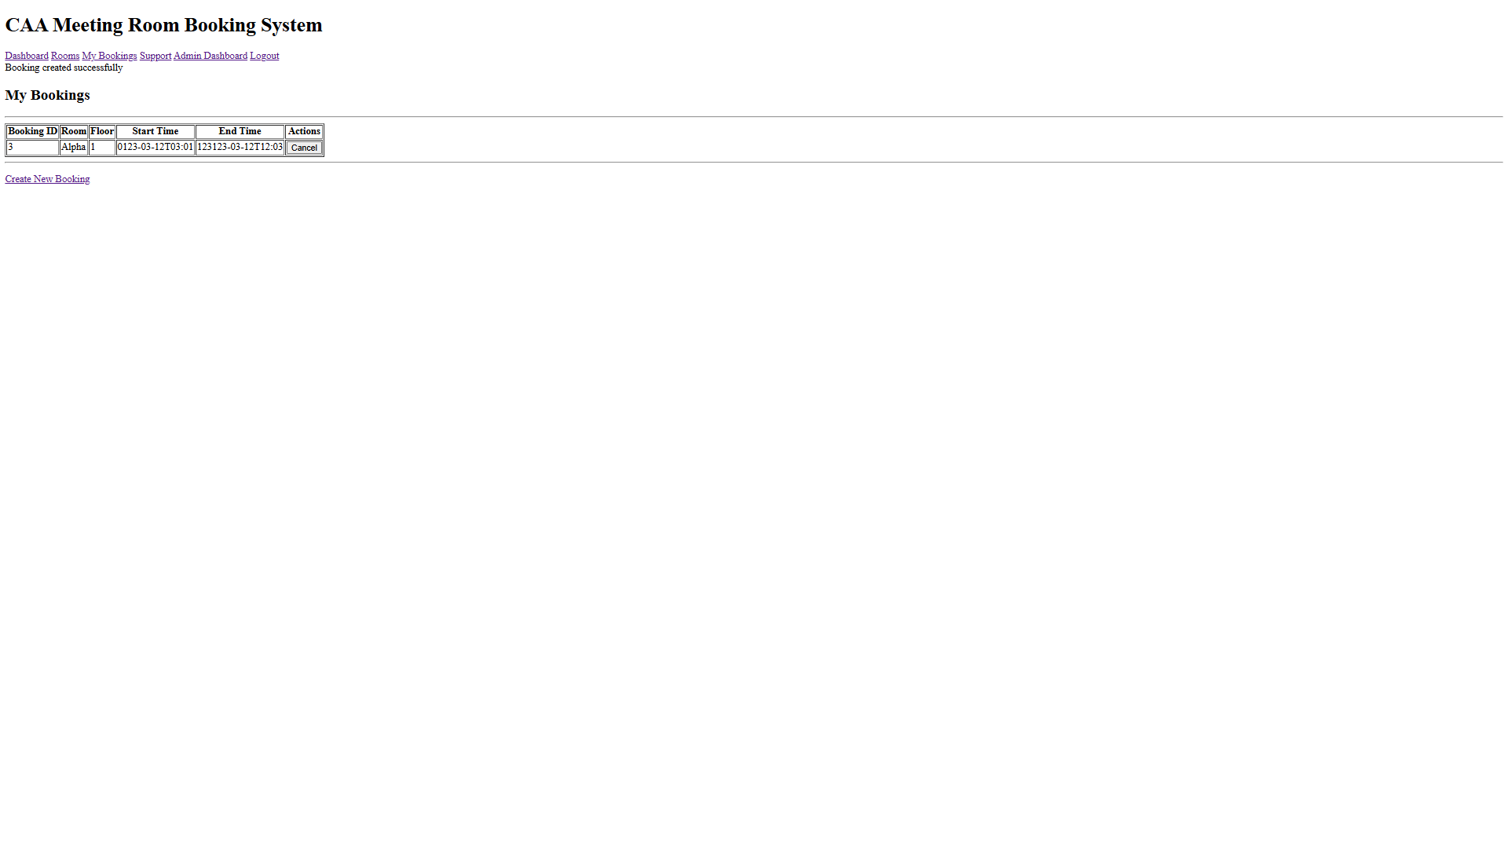

Rooms list page
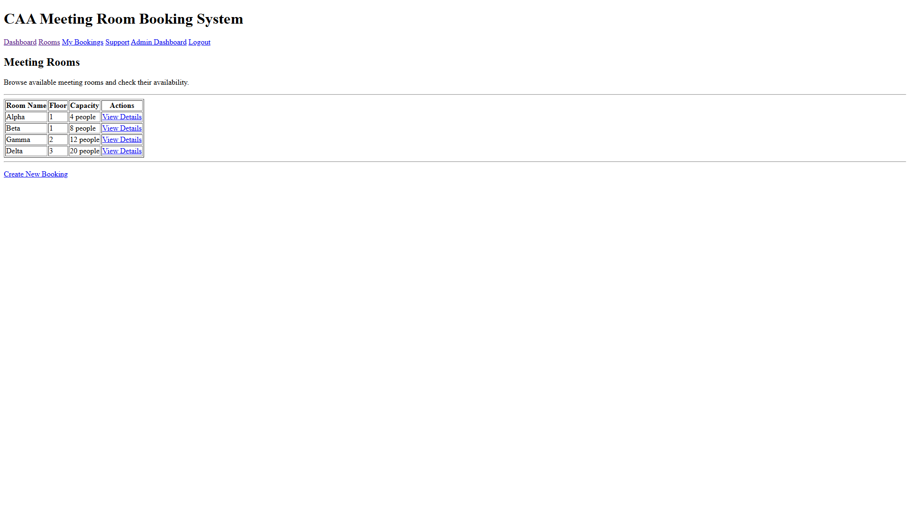

My bookings
•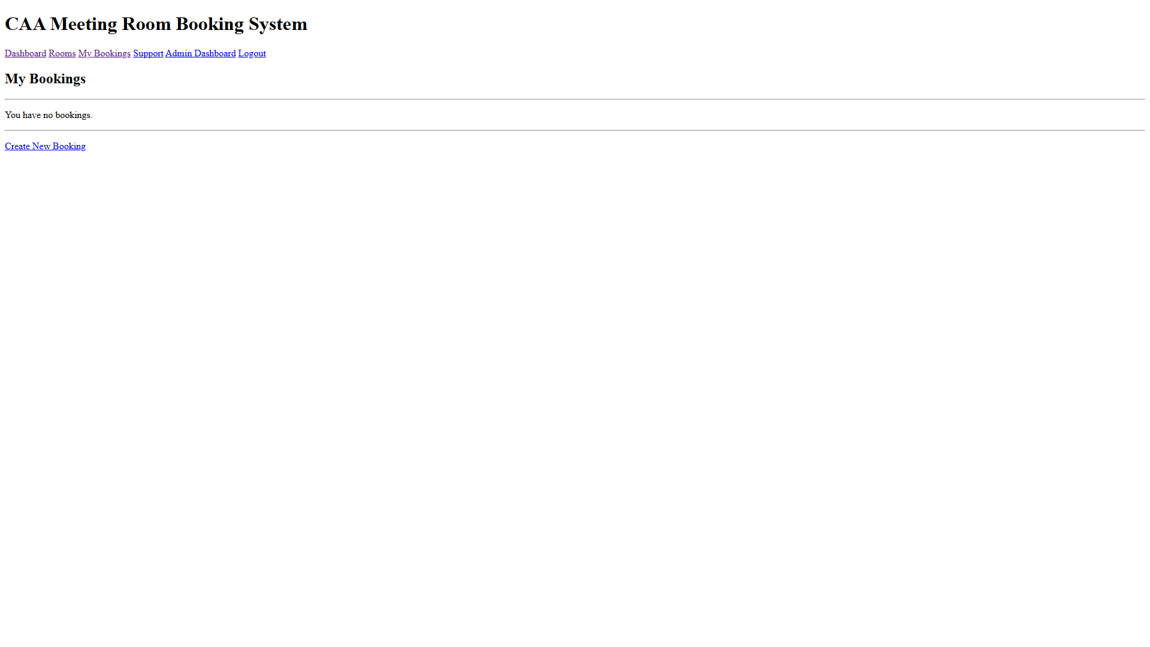

create a new booking
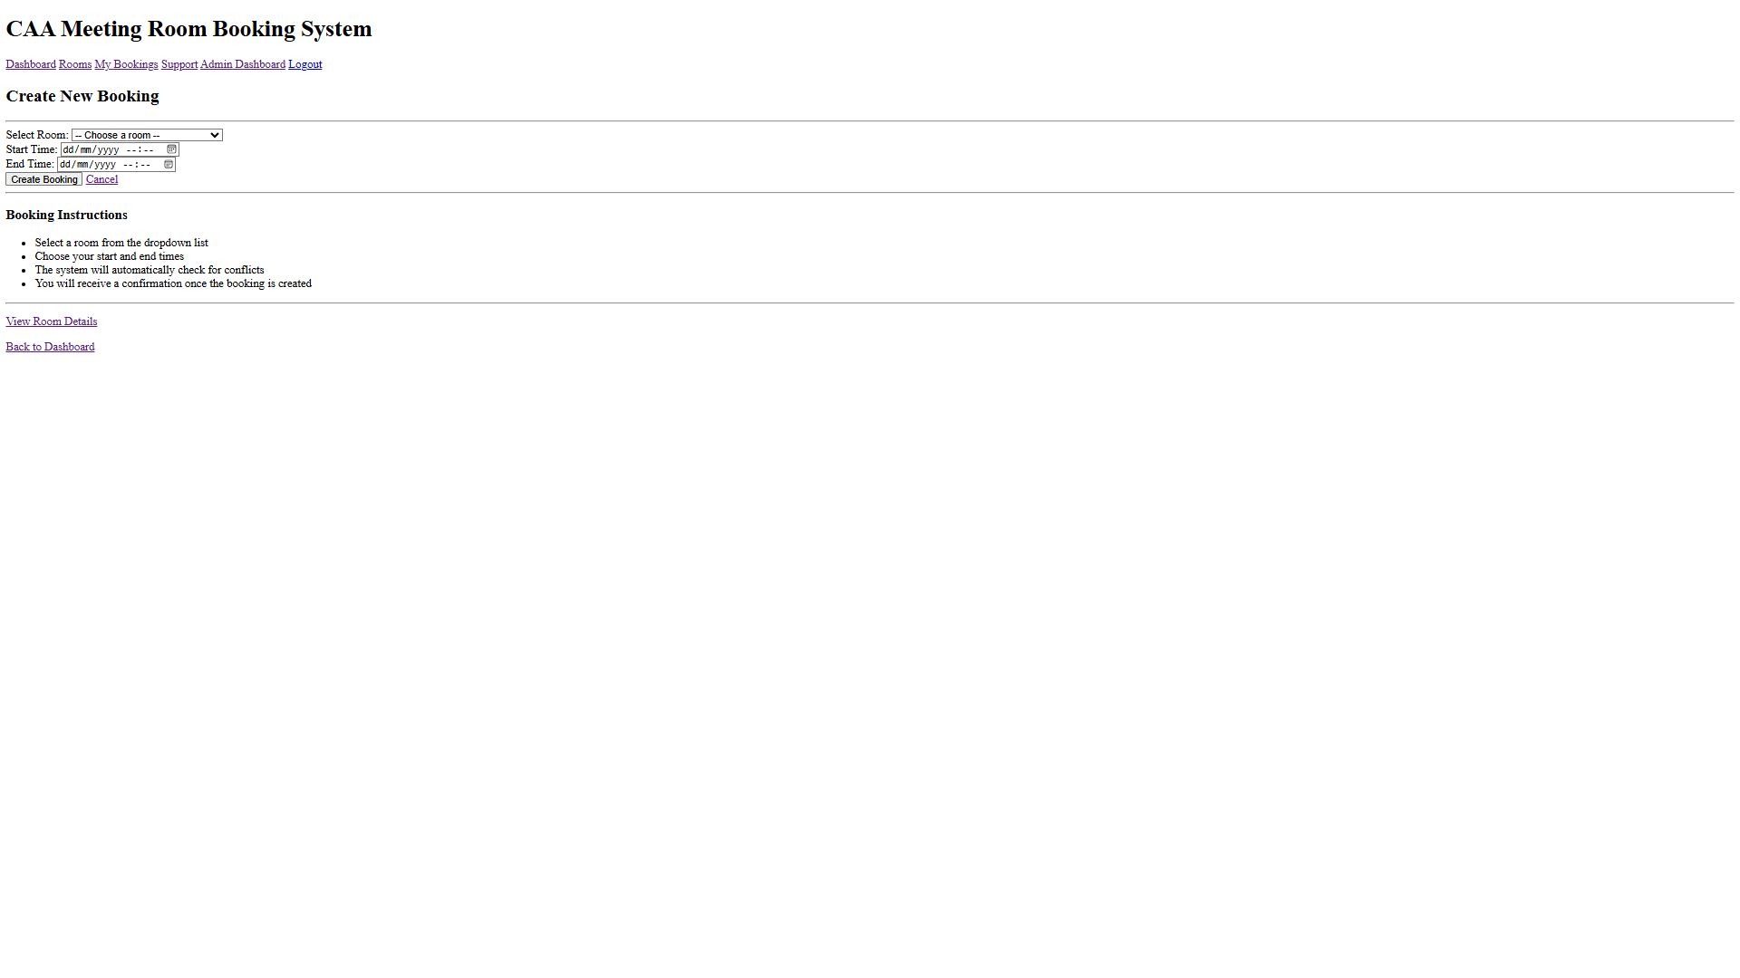

Select a room

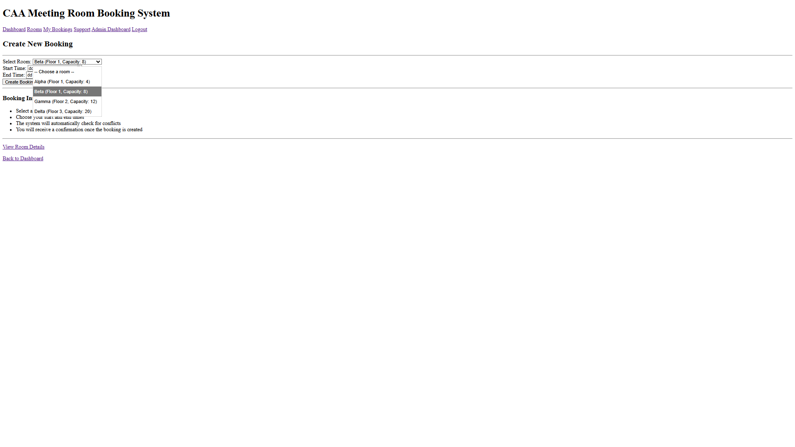

Select dates
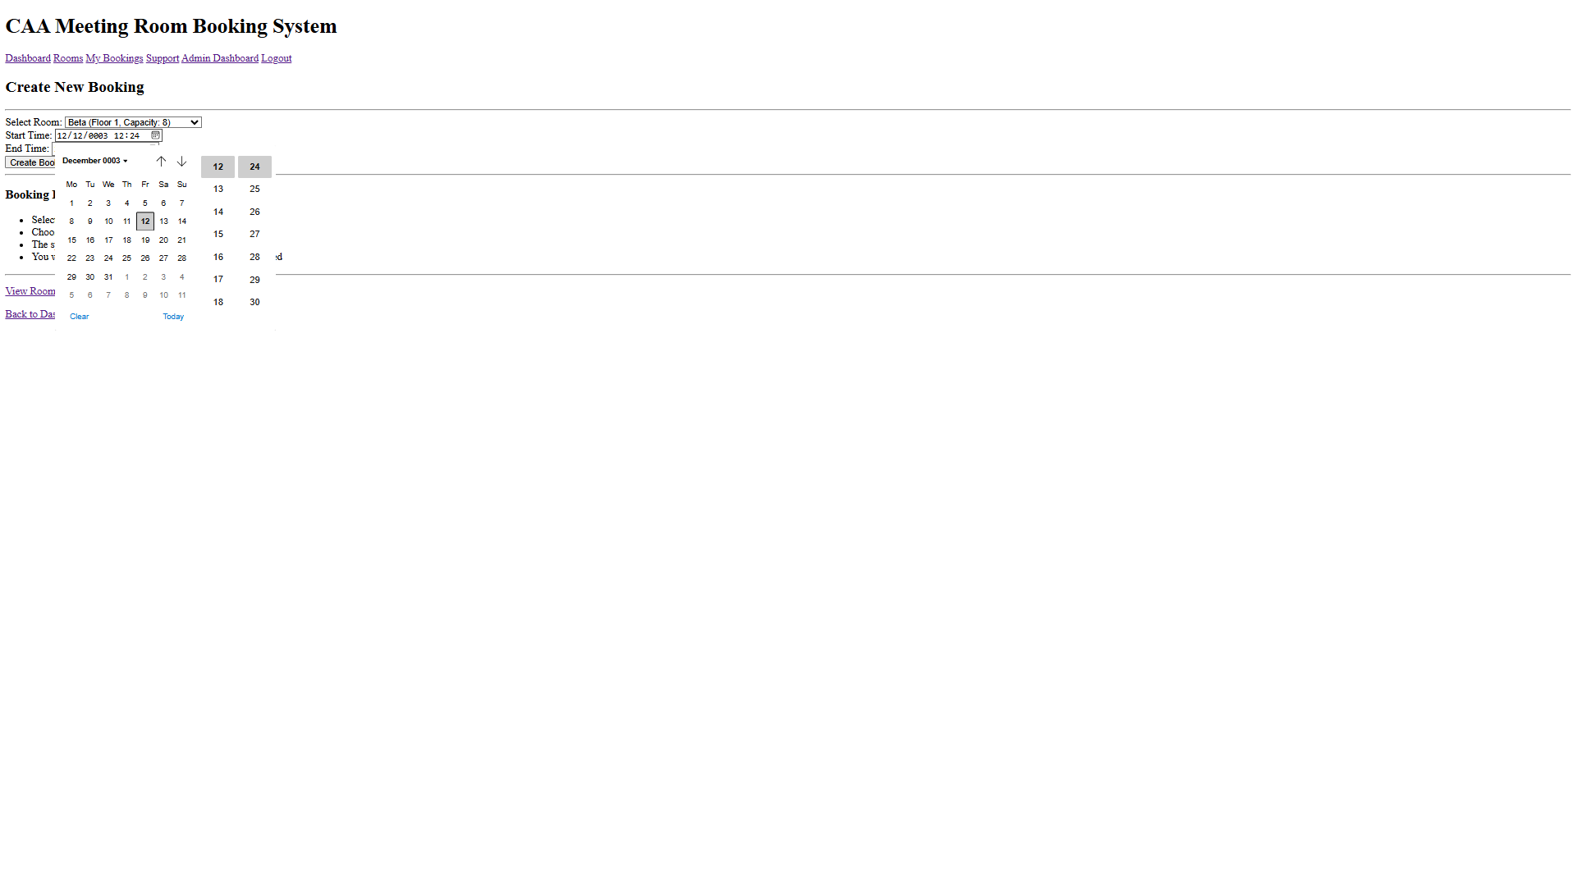

Booking details
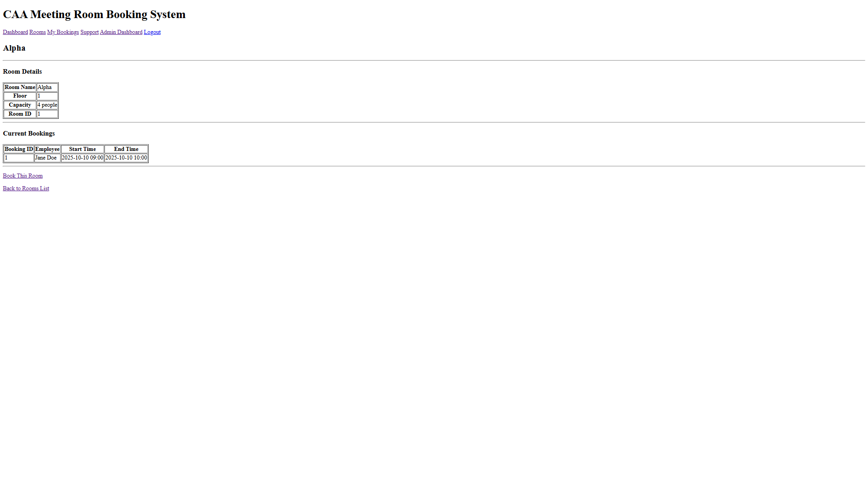

Support page
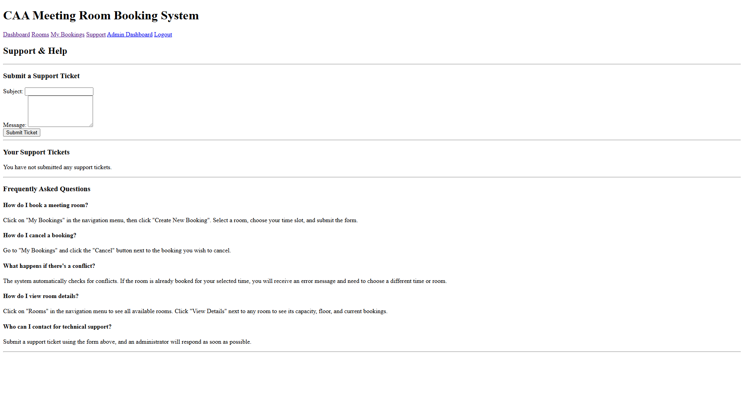

Admin dashboard
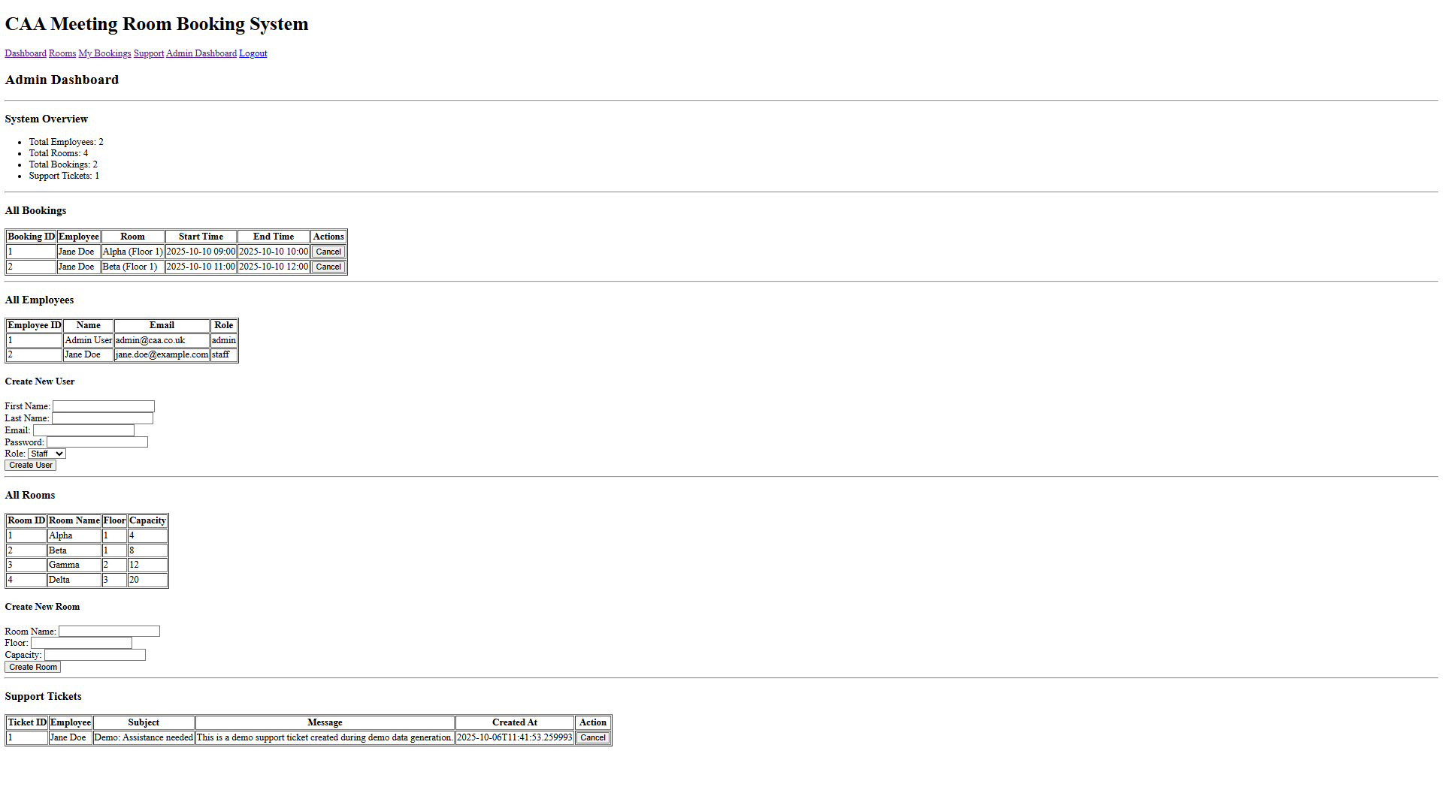

Evaluation of current system
The current system has most of the objectives built and finished. The dashboard is straightforward, allowing staff to quickly view their meetings and easily access other sections. It addresses the issue of lacking a central location for booking information and performs significantly better than the previous paper method.
One of the best aspects is the room browsing and booking feature. Staff members can see all available rooms, check their sizes and equipment, and make bookings without needing to contact the admin.
The 'My Bookings' page is also impressive. It displays all current and future reservations in a single location. This means staff no longer must repeatedly ask the admin or check notice boards for meeting times. The admin dashboard also allows approved users to manage everything without needing to code. Admins can add users, modify room details, and review all bookings from one central location, which simplifies their responsibilities.
The whole auth flow works perfectly too. Users can securely log in using their company email and password, with different levels of access determined by whether the individual is regular staff or an admin.
The booking validation is also very reliable. The system prevents incorrect booking times, avoids overlaps, and enforces limits such as maximum booking durations and room capacities. This reduces the errors that were common in the old system and ensures that everyone can rely on the bookings they see.

Shortcomings and improvements
The prototype works well for the main stuff, but it still needs some fixes before it can be used in production. Most of the problems came from running out of time and just focusing on the big features.
One big issue is that it doesn’t send email alerts when someone books, cancels, or changes a meeting. This means people might forget their meetings or not know if something changed. I will add Mailjet API to send confirmation and reminder emails, so everyone stays in the loop.
Another problem is users can't change their own bookings. They can only see and cancel them, but to change the time or room, they must cancel and start over. I will add an ‘Edit Booking’ option so they can change things directly and avoid mistakes.
The backend code for bookings needs work. Right now, admins must do everything, which isn’t user-friendly. I will have It ready by production ready version so users can edit, cancel, and check in without needing admin help. This would make the system easier for everyone.
The 60-minute buffer between meetings isn’t working either. Right now, meetings can be back-to-back, which can be a problem. I’ll add a rule for a gap between bookings or at least warn users if they try to book right after another meeting.
Also, even though this coursework project is supposed to be mainly more about function over aesthetic the UI is really annoying me being quite ugly. I’ll have probably a CSS library like tailwind and some stuff reorganised so that it looks nicer
Lastly, there’s no way to track support tickets. Users can submit tickets, but they can’t see what’s happening with them. I’ll add a ticket tracking system via notifications via email so users can check their ticket status, and admins can manage them better.

